Winners Announced at Marion County Medical Society Research Symposium
Please join us to congratulate the Ocala Surgery, Family Medicine, Internal Medicine and Transitional Year Programs for the outstanding research posters at the Marion County Medical Society Research Symposium. Their work was presented at the FMA 2020 David A. Paulus, MD Meeting, which was held virtually this year!
The symposium had a total of 24 submissions ending with ties for 1st, 2nd and 3rd place!
The winners, their poster titles and their faculty advisors are:
1st Place:
Whiyie Sang (Surgery): Robotic Major Hepatectomy: Influence of age on clinical outcomes –Darwin Ang
Vincent Ly (Family Medicine): Toasted Skin Syndrome? – Julia Fashner
2nd Place:
Sai Guduru (Internal Medicine): In-hospital outcomes based on timing of administration of P2Y12 inhibitors in Non-ST Elevation Acute Coronary Syndrome patients – Khalid Abusaada
Faluk Mohammed (Internal Medicine): Challenges in Managing Acute Myocardial infarction associated with infective endocarditis: an abstract of a Case Report and Literature Review – Khalid Abusaada
3rd Place:
Sushma Patlolla (Internal Medicine): Evaluating Hospital Mortality Rates of Diabetic Patients with Sepsis Based on Hour of Antibiotic Administration – Khalid Abusaada
Laura Valente (Transitional Year): Relationship between Hour of Antibiotic Administration and In-Hospital Mortality for Patients with Sepsis in HCA North Florida Division Hospitals – Alan Hamza
Thank you for your hard work!

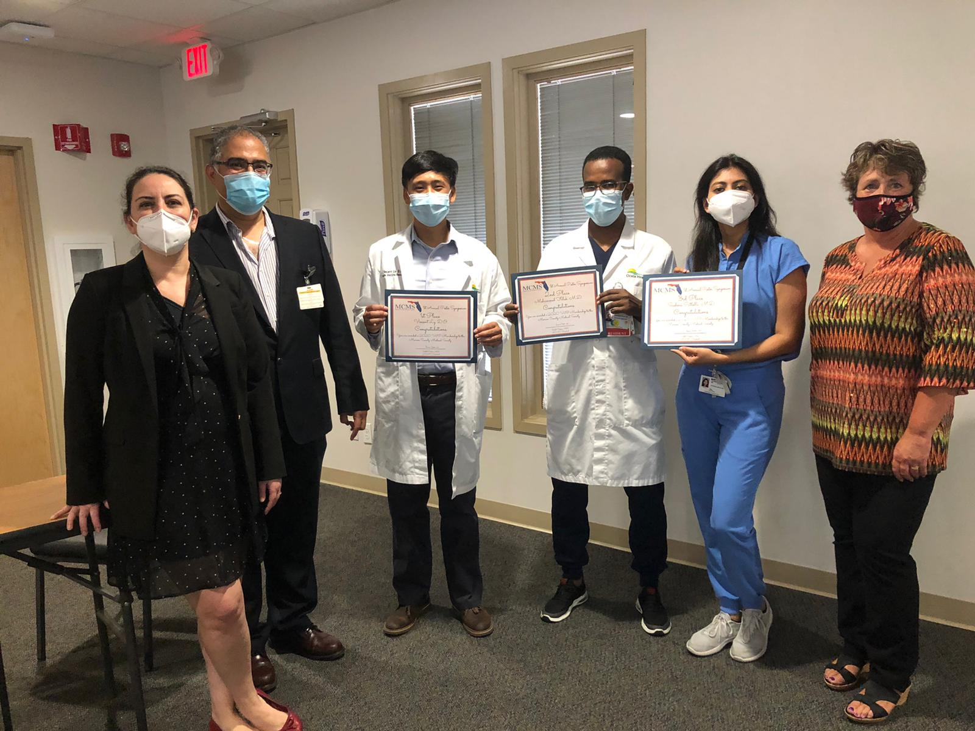
Hale Toklu, Cristobal Cintron, Vincent Ly, Mohammed Faluk, Sushma Patlolla and Sherry Budnick (Marion County Medical Society Executive Director) at the Marion County Medical Society Research Symposium.
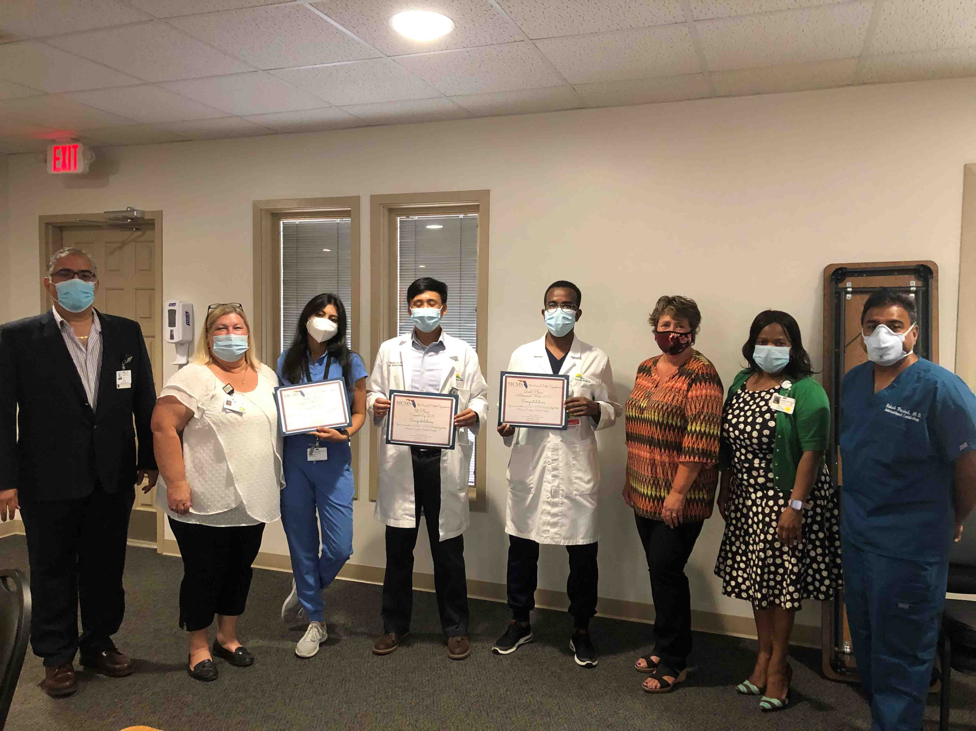
Cristobal Cintron, Sandra Eldridge, Sushma Patlolla, Vincent Ly, Mohammed Faluk, Sherry Budnick, Jacklyn Fuller (Ocala ADME) and Rakesh Prashad at the Marion County Medical Society Research Symposium.
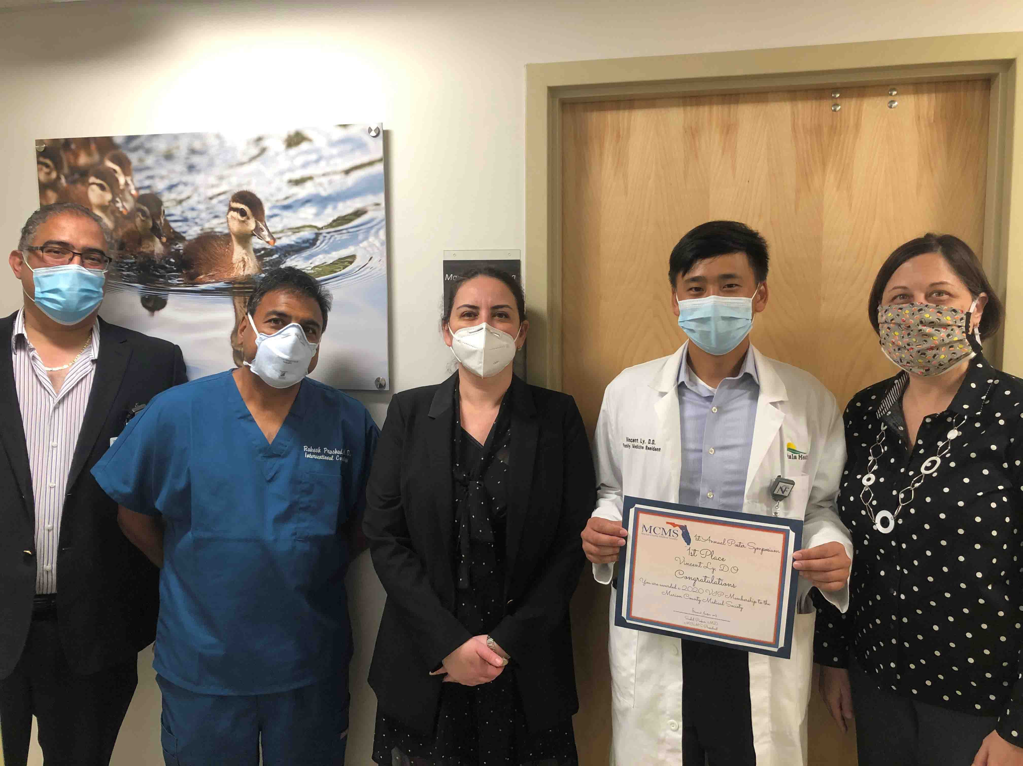
Cristobal Cintron (Research coordinator), Rakesh Prashad (Research Advisory Commitee Chair), Hale Toklu (Research Director), Vincent Ly (first place winner) and Julia Fashner (his faculty advisor and Family Medicine Program Director) at the Marion County Medical Society Research Symposium.

