A Malpractice Solution at Competitive Pricing for
Marion County Professionals

MCMS, together with McGriff -Chazal Insurance and MedPro Group, has worked diligently to develop an industry-leading healthcare liability solution for MCMS member physicians.

PROGRAM HIGHLIGHTS

• Superior coverage with flexibility — each physician may choose his or her own policy limits and policy type: Occurrence, convert to occurrence or Claims-made coverage
• A pure consent to settle provision
• Free retirement tail after one year of paying a mature rate, regardless of age
• Superior risk management solutions
• $50K cyber liability coverage at no additional charge
• Prior acts coverage available

CARRIER’S NATIONAL HIGHLIGHTS

Healthcare liability insurance is provided by the national leader: MedPro Group
• A Berkshire Hathaway company that has defended physicians since 1899
• Unsurpassed financial strength ratings: A++ (A.M. Best) and AA+ (Standard & Poor’s)
• 400,000+ malpractice cases handled over MedPro’s history
• 80% of cases closed without payment
• 90% trial win rate
• 200,000+ insureds

~Join your colleagues at MCMS and begin saving today~

For a free quote please contact Charles Chazal
cchazal@mcgriff.com or call 352-547-1302
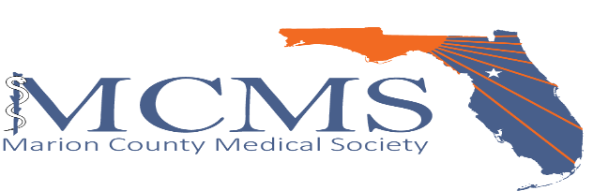

A.M. Best rating as of 7/21/2016. Standard & Poor’s rating as of 2/19/2016. All data is MedPro Group data; claims data range is 2006-2017 unless otherwise indicated. MedPro Group is the marketing name used to refer to the insurance operations of The Medical Protective Company, Princeton Insurance Company, PLICO, Inc. and MedPro RRG Risk Retention Group. In order to qualify for a free tail, you must also have a retroactive date at least 48 months prior to the date of retirement and be insured by the company for 12 months. All insurance products are administered by MedPro Group and underwritten by these and other Berkshire Hathaway affiliates, including National Fire & Marine Insurance Company. Product availability is based upon business and regulatory approval and may differ among companies. Visit medpro.com/affiliates for more information. ©2017 MedPro Group Inc. All Rights Reserved.

